|  |  |
| --- | --- |
|  | **University of Dhaka**  **Department of Computer Science and Engineering**  **CSE 3111 – Computer Networking Laboratory Credits: 1.5 Batch: 27/3rd Year 1st Sem 2023**  Instructors: Prof. Dr. Md. Abdur Razzaque (AR), Prof. Dr. Md. Mamun-Or-Rashid (MOR), Dr. Muhammad Ibrahim (MIb) and Mr. Md. Redwan Ahmed Rizvee (RAR) |

**Lab Experiment # 7**

|  |
| --- |
| **Name of the Experiment:** Implementation of Link State Routing Algorithm |

**Objective:**

The purpose of this experiment is to develop an understanding of the Link State Algorithm and its applications in computer networks by implementing the algorithm.

**Introduction:**

The Link State Algorithm is a widely used routing algorithm in computer networks. It enables routers to create a map of the entire network topology and compute the shortest path to each destination. In this lab, you will design and implement a program that simulates the Link State Routing Algorithm, demonstrating its functionality and gaining practical experience in using the algorithm for routing purposes.

**Procedure:**

* Design a program that simulates a network of routers, where each router is represented as a graph node, and each link is represented as an edge with a given cost.
* Each router will have a mapping of **port and router names**.
* Implement the Link State Algorithm including the following components:
  1. Creation of a network topology :
     + First Read the list of edges for each router
     + Create Link State Packet (LSP) containing id, TTL, cost of immediate edges and send to all neighbors.
     + Neighbors will broadcast it to their neighbors and so on – this is called flooding.
     + After a node has received a new message, it will run Dijkstra and calculate the current shortest path to all other nodes.
  2. Maintenance and updating of the network topology based on LSPs [Cost will change randomly after certain time interval ]
  3. The program should be able to output All pair Shortest Paths for each node.
* Analyze the performance of the algorithm in terms of time complexity, number of messages sent, and memory usage.
* Test the functionality of the Link State Algorithm in various network scenarios by changing the network topology and evaluating the calculated shortest paths. This can be done by using a 30 second timer which randomly updates an edge [The initial network topology should be configurable from a file ]

**Results:**

Include the following in your lab report:

* A detailed description of the program, including the implementation of the Link State Routing Algorithm, the network topology used, and the methods employed for simulating the LSP distribution and topology updates.
* Screenshots or console output demonstrating the correct functionality of the program in various network scenarios.
* A discussion of any issues or challenges encountered during the implementation process and the steps taken to resolve them.
* An analysis of the algorithm's performance, including time complexity and memory usage.
* Print the gradual updates of path in each node

**Conclusion:**

Summarize the results of the experiment and discuss the key takeaways from implementing the Link State Algorithm. Reflect on the importance of this routing algorithm in computer networks and its practical applications.

**References:**

Include any relevant references or resources used during the lab experiment, such as textbooks, online tutorials, or official documentation.

**Sample Input Graph:**

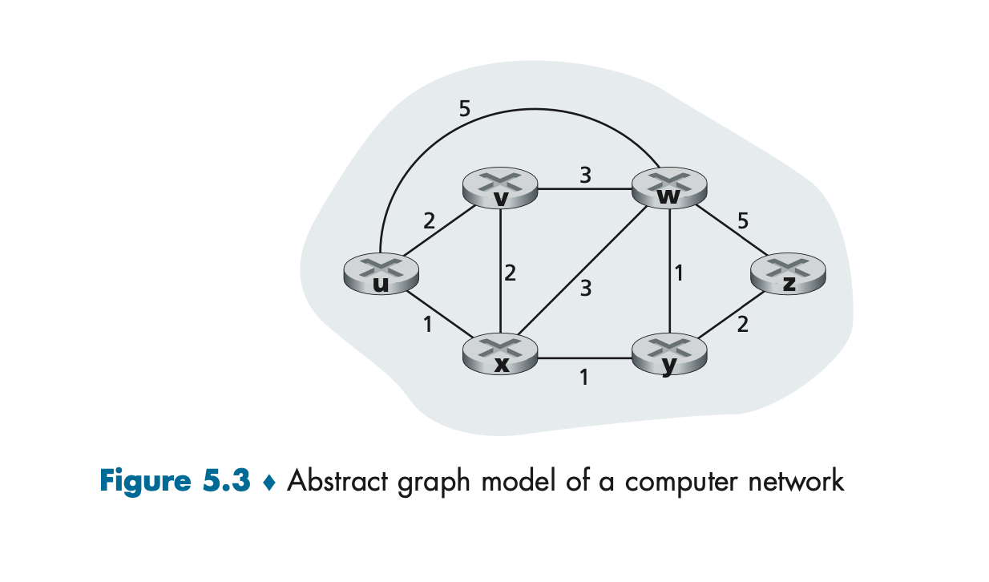

**Message from U:**

id : u1

TTL : 6

Links:

u-v : 2

u-x : 1

u-w : 5

**Sample Result**

